**Question 1 [10 Points] [Answer on the answer-script]**

|  |  |
| --- | --- |
| **CGPA (Input)** | **Award (Output)** |
| **below 2** | **Fail** |
| **2 to 3.49** | **Pass** |
| **3.5 to 3.64** | **Distinction** |
| **3.65 to 3.79** | **High Distinction** |
| **3.8 or above** | **Highest Distinction** |

Draw **flowchart** of a program that asks the user for CGPA as input and then prints the award message.

Do NOT use more than seven “**print/output”** boxes**. If the user inputs any CGPA outside the range 0🡪4, print “invalid”.**

Example1: If user gives 3.6 as input, then print “Distinction” as output.

Example2: If user gives 1.5 as input, then print “Fail” as output.

Example3: If user gives **-** 4 as input, then print “Invalid” as output.

Example4: If user gives 9 as input, then print “Invalid” as output.

**Question 2 [10 Points] [Answer on the answer-script]**

Draw **flowchart** of a program that asks the user for two inputs (the value of **n** and **firstTerm**) and then prints summation of the series as shown below. Please note that every third term has a negative sign.

Example1: If user gives **2** and **8**, then print **24** (because sum of first **TWO** terms of **EIGHT**’s series is 8+16 = 24).

8 + 16 **-** 24 + 32 + 40 **-** 48 + 56 + 64 **-** 72 + 80 + 88 …….. up to nth term

Example2: If user gives **5** and **6**, then print **54** (because sum of first **FIVE** terms of **SIX**’s series is 6+12**-**18+24+30 = 54).

6 + 12 **-** 18 + 24 + 30 **-** 36 + 42 + 48 **-** 54 + 60 + 66 …….. up to nth term

**Question 3 [5 Points] [answer on the answer-script]**

Write **javacode** of a program that prints your name. Take special care about spacing, capitalization and location of brackets.

**Question 4 [10 Points] [answer on question paper]**

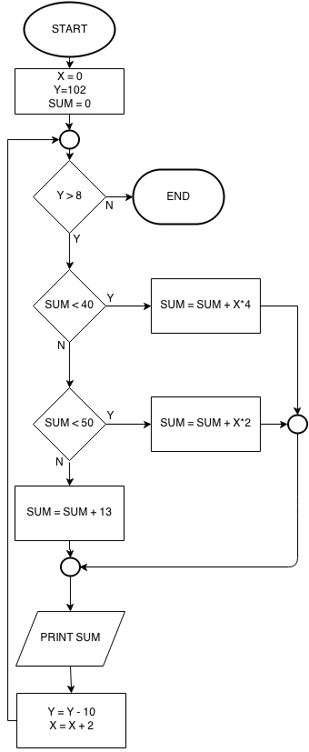

#### 

**Note**:

There may be more or less output boxes

than necessary. Draw more if needed.

Write output on the question paper

**OUTPUT:**

|  |
| --- |
|  |
|  |
|  |
|  |
|  |
|  |
|  |
|  |
|  |
|  |
|  |

in the boxes given below: